























EST
Tenacious
Nurturing
Progressive
Open
OUR VALUES
OUR PRIORITIES
We will prevent homelessness wherever possible
We will deliver effective support
We will deliver sustained support
We will continue to be an employer of choice
We will continue to be well managed and efficient
We will communicate clearly
OUR MISSION
To maximise independent living and prevent homelessness in our community by offering a hand up - housing, support and care - to the most vulnerable.
To enhance understanding and compassion towards homeless people in our community through education and advocacy.
S
s
S
1972
Registered charity 802013 www.stmartinshousing.org.uk
@stmartinsnfk
01603 667706

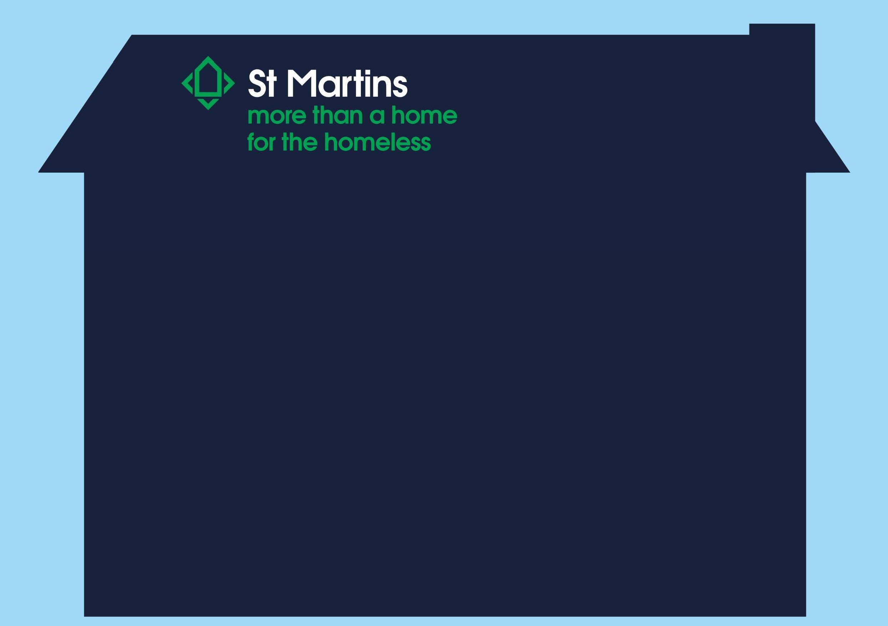
Strategic Plan 2024 – 6
6 priorities to deliver our plan: Ending rough sleeping on our streets
3) We will deliver sustained support
We will:

Implement the new Care Quality Commission (CQC) assessment framework and continue to maintain Outstanding rating (Highwater House) and improve from Good to Outstanding (Webster Court)

Increase capacity at Webster Court (4 additional rooms).

Review our Magdalen Road service

Provide a diverse range of learning and development opportunities to the people we support.

Provide evidence which will identify gaps and influence the commissioning of services to better meet the needs of the people we support.
2) We will deliver effective support
We will:

Deliver support that is person centred and trauma informed, building rapport and understanding of the causes of homelessness. Support will build confidence and greater independence to prevent reoccurring homelessness

Work in partnership with local services to support individuals who are roofless, providing an outreach support service that is proactive, reactive and flexible to meet changing needs

Support our local authority to deliver on their commitment to safeguard people at risk of sleeping rough during periods of severe weather and over the winter months

- We will prevent homelessness wherever possible
We will:

Support people in the community to maintain their accommodation and prevent further incidents of homelessness

Provide clear signposting to a range of support services that prevent homelessness and assist with independent living.

Provide temporary or short-term housing using a trauma informed approach
Provide housing led/first options to people who face multiple barriers, exclusion and entrenched homelessness were possible.
Ensure the continuous professional development of our team.
Work closer with safeguarding adults board to highlight and learn how to manage complex cases.

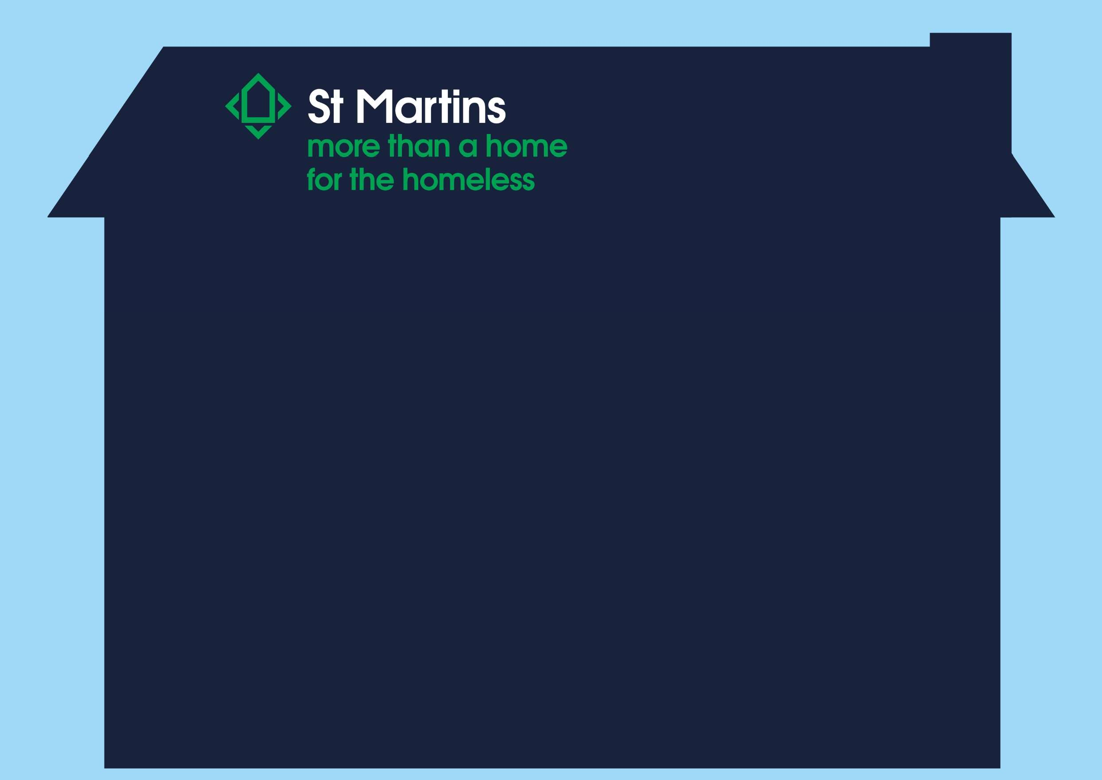
Strategic Plan 2024 – 6
6 priorities to deliver our plan: Ending rough sleeping on our streets
6) We will communicate clearly
We will:
Provide clear leadership on all homelessness related issues
Speak openly and passionately about our work and its impact
Use a range of media channels to increase the understanding of the importance of our work
Use every interaction as an opportunity to talk about our work
Use our fundraising events as opportunities to talk about the importance of our work.
Build on and develop relationships / partnerships with local organisations and education establishments
Engage with all generations of supporters (5-105 years old)
Communicate regularly with all our supporters and stakeholders and continue to remain the prominent / trusted local charity
5) We will continue to be well managed and efficient
We will:
Undertake annual consultations with the people we support to monitor quality
Undertake regular engagement with St Martins Advisory Group (Adult and Youth)
Support and development of our volunteers
Exceed expectations on the delivery of commissioned contractual requirements
Adhere to external Codes of Practice
Continue to build on our solid infrastructure with sound financial monitoring and reporting
Ensure we have clear structures, systems and lines of accountability
Ensure we undertake regular audits, property and system checks and use technology to its full advantage
4) We will continue to be an employer of choice
We will:
Provide strong, clear, fair and inspirational leadership
Recognise, value and reward the skills and expertise of our team.
Provide comprehensive inductions, ongoing learning and development, support and progression opportunities
Develop and maintain a healthy culture
Continue with a leadership/management plan to equip managers with skills needed
Continue to follow the NJC scales and review the job family ranges periodically
Review and enhance the St Martins recruitment, induction and retention processes
Hold a St Martins Conference
Ensure job descriptions are linked to behaviours and our culture
Utilise the apprenticeship pot to offer apprenticeships to current team members and new apprentices
Continue to develop our healthy workplace and wellbeing support packages

